Continue from Step 18 from the previous instructions.

1. Using length 10 black rods, place a touch sensor at the very front of the robot. Put a red rod inside the touch sensor.

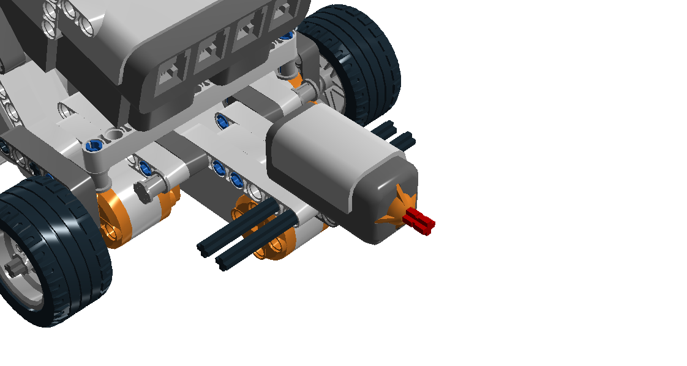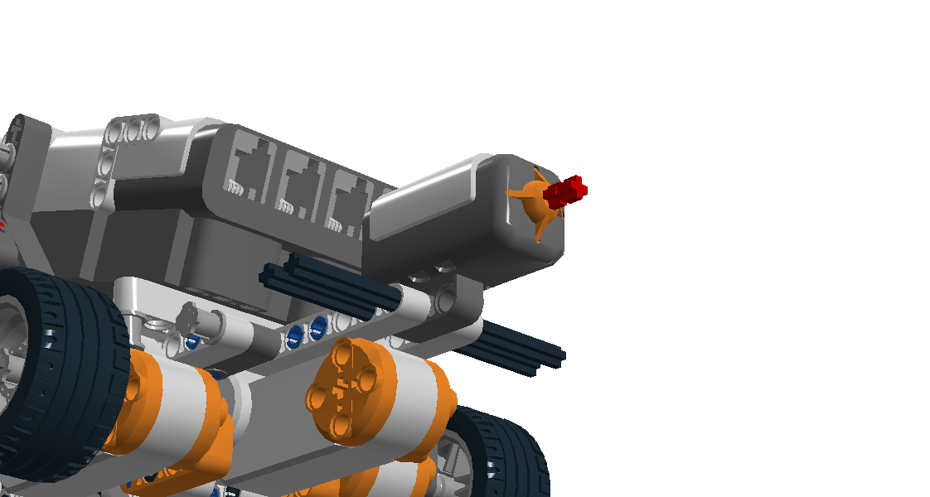

1. Add a 4x6 bent piece to the side, and then add a long black connector to both sides next to the bent piece.

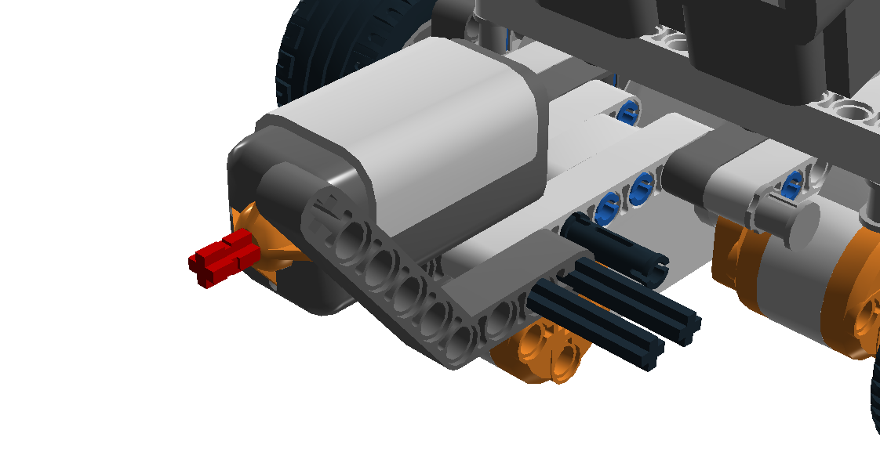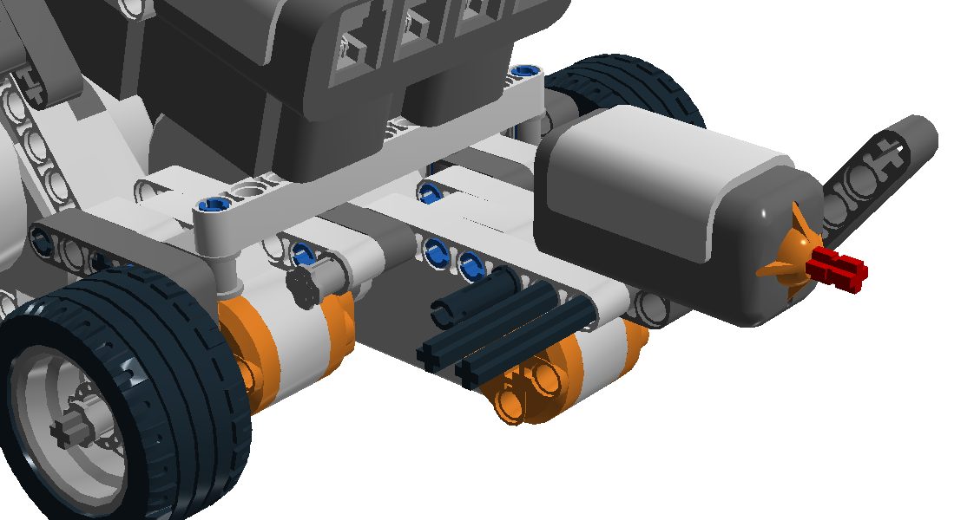

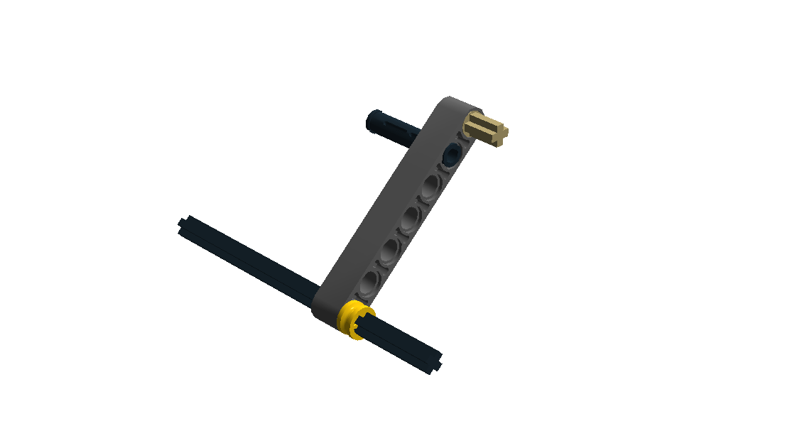**3.** Build this using a length 10 black rod, same size as before.

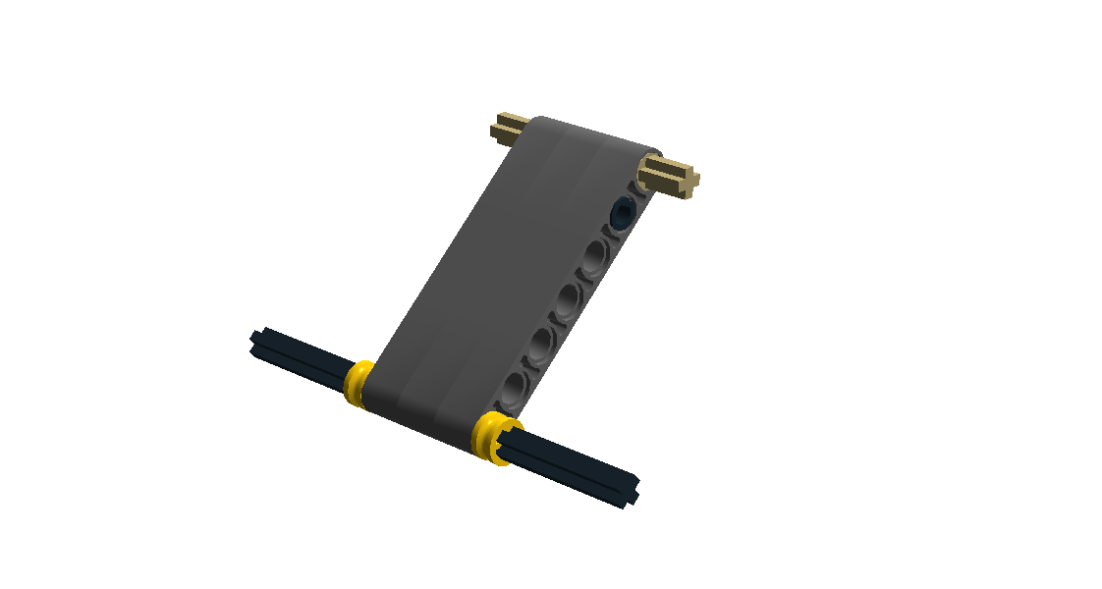

1. Finish the piece by adding two more length 7 grey pieces, then adding a yellow ring to the pole and the last beige connector.

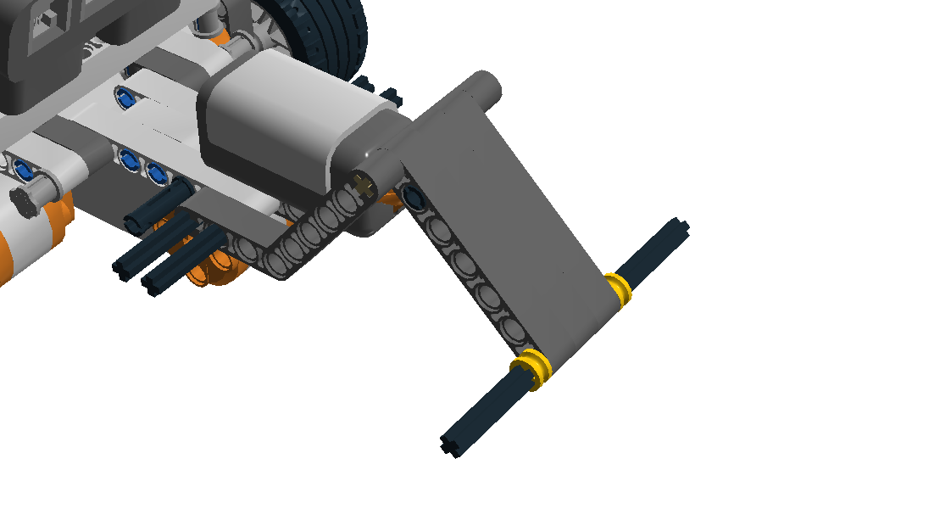**5.** Attach the part to the front using another 4x6 bent piece.

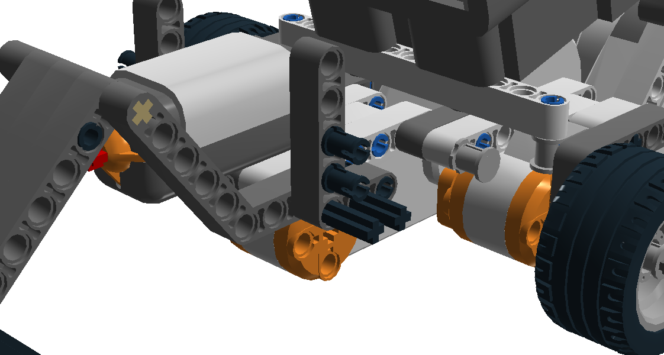**6.** Attach L pieces to both sides of the robot, adding black connectors for the next piece to come.

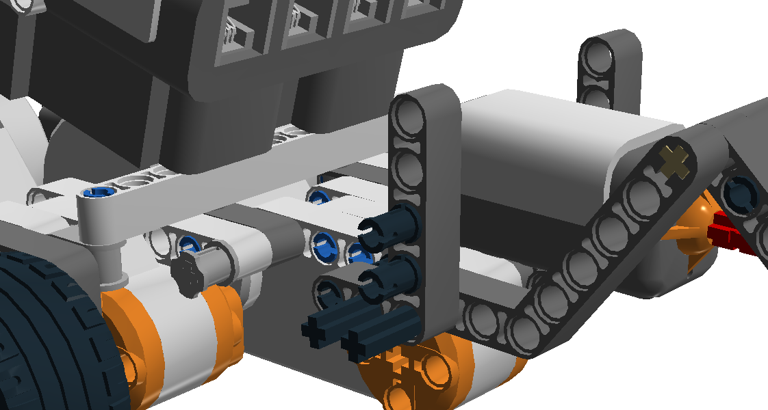

**7.** Attach two light (not color!) sensors to the L pieces on both sides.

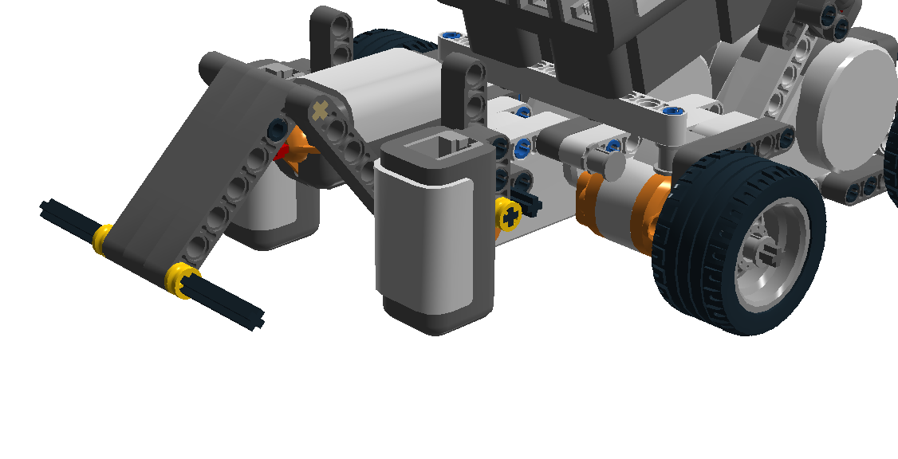

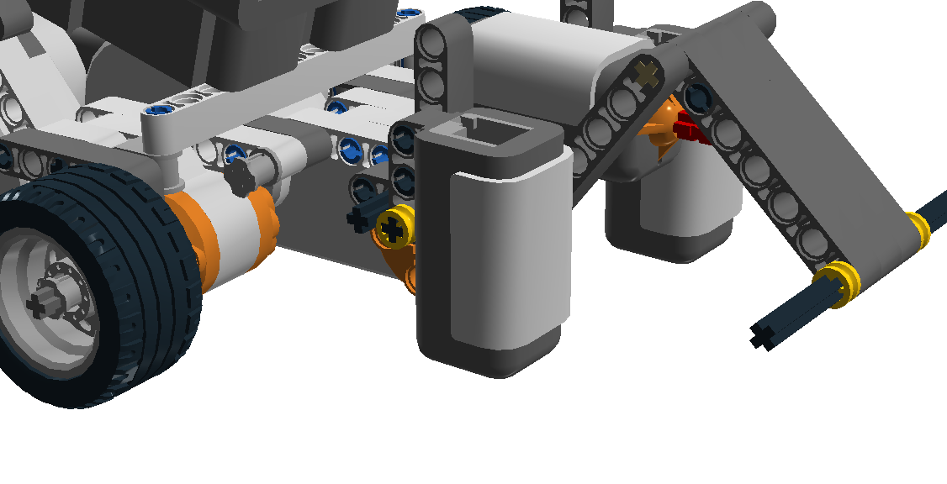

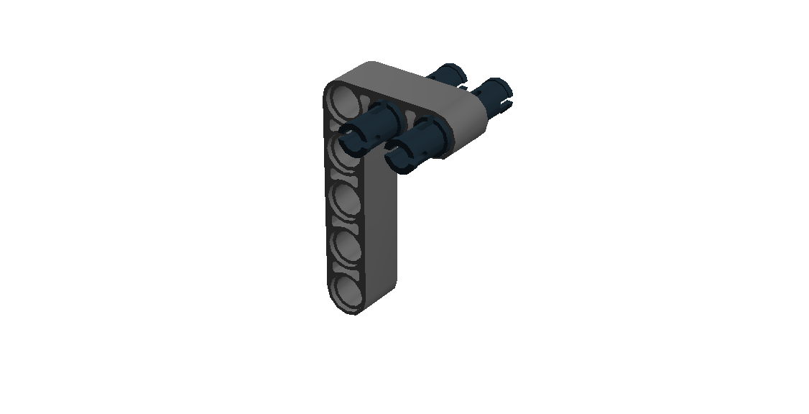**8.** This will be used to hold the ultrasonic sensor.

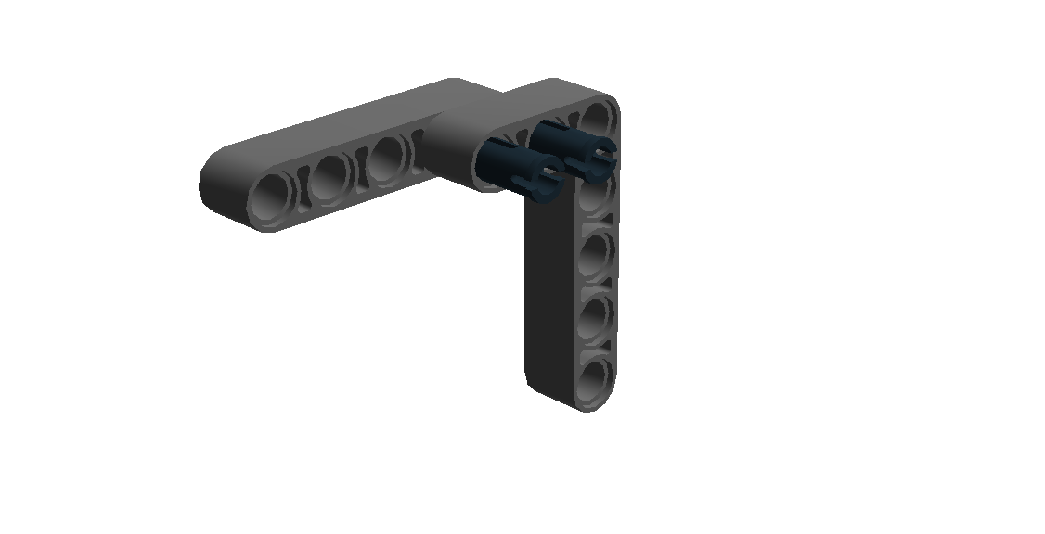**9.** Use long black connectors to secure the ultrasonic sensor between the two pieces.

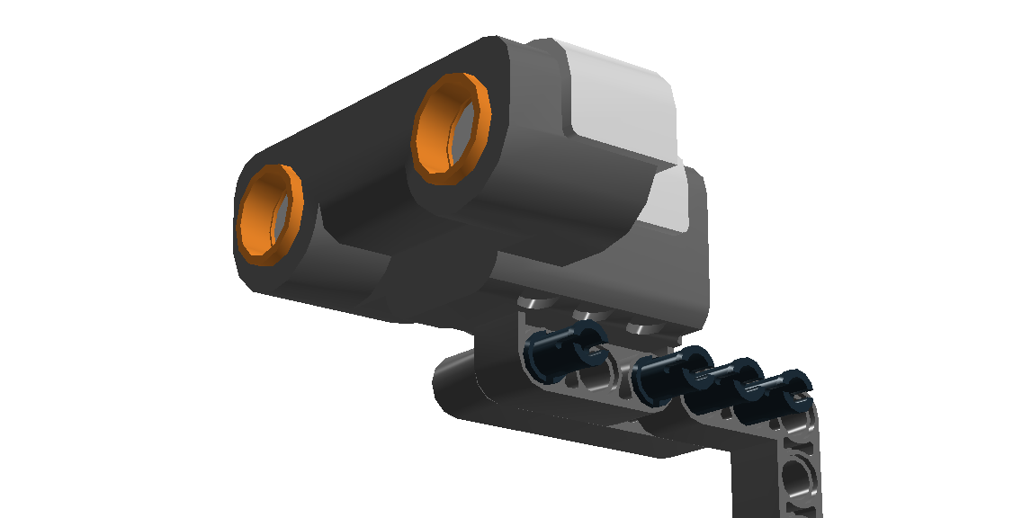

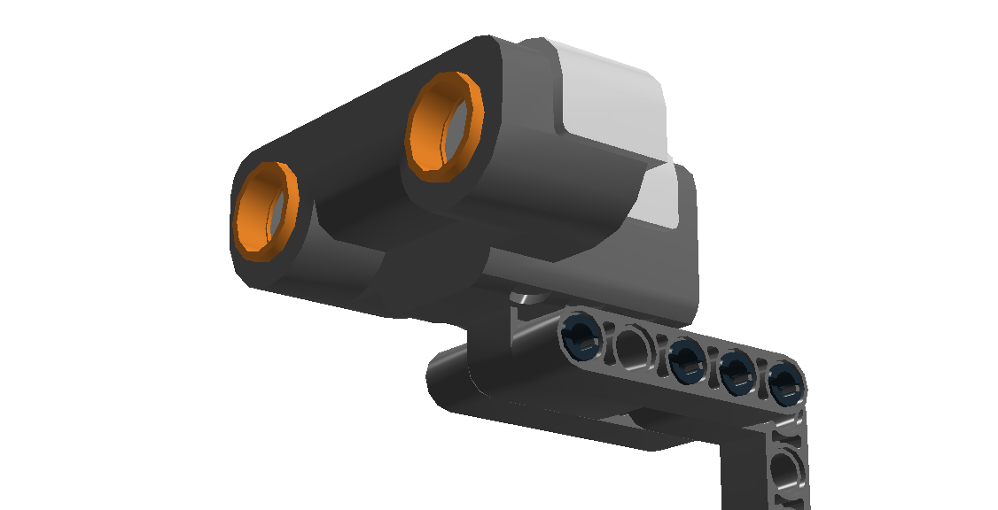

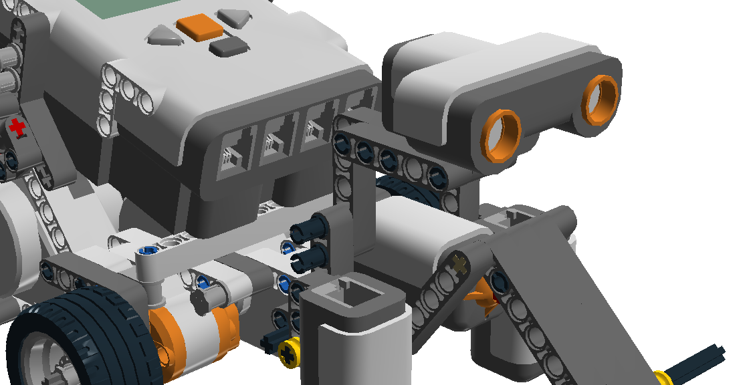**10.** Finally, attach the part to the L piece on the right side using long black connectors.

**11.** Attach the right motor to the A port and the left motor to the C port. Attach the ultrasonic sensor to port 1, the touch sensor to port 2, the right touch sensor to port 3, and the left touch sensor to port 4.